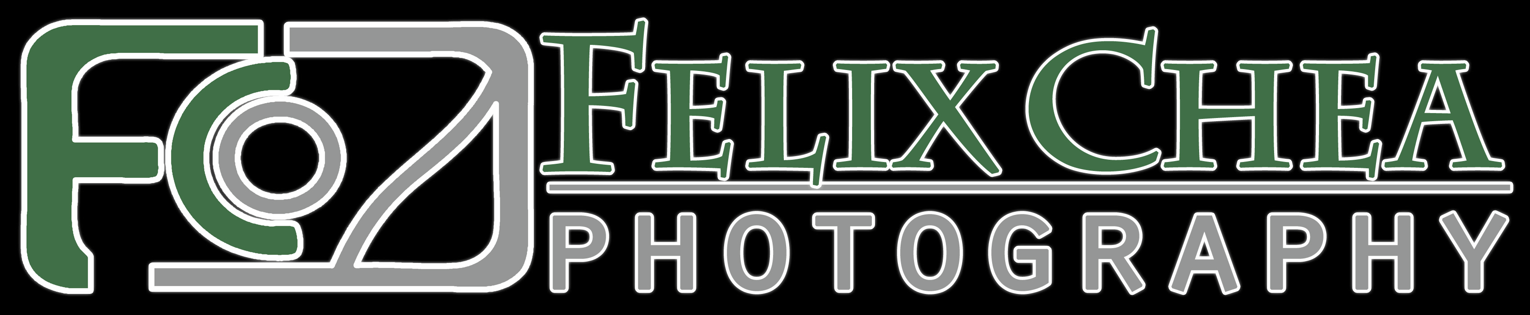
Phone: 267-259-5678
Email: felixcheaphoto@yahoo.com www.felixcheaphotography.com

DATE OF SIGNING: ________________________

WEDDING PHOTOGRAPHIC SERVICE AGREEMENT
 |  |  |  | DATE OF WEDDING
BRIDE |  |  |  | GROOM
STREET |  |  |  | STREET
CITY, STATE, ZIP |  |  |  | CITY, STATE, ZIP
HOME PHONE |  | CELL PHONE |  | HOME PHONE |  | CELL PHONE
EMAIL |  |  |  | EMAIL
GETTING READY LOCATION |  |  |  |  |  | TIME
CEREMONY LOCATION |  |  |  |  |  | TIME
RECEPTION LOCATION |  |  |  |  |  | TIME
NUMBER IN WEDDING PARTY | NUMBER OF GUESTS ATTENDING |  | NUMBER OF BRIDESMAIDS |  | NUMBER OF GROOMSMEN |  | FLOWER GIRL  YES NO | RING BEARER  YES NO
PARENTS  ATTENTING |  | STEP PARENTS  ATTENDING |  | GRAND PARENTS  ATTENDING |  | OTHER KEY  PEOPLE
PHOTOGRAPHY SERVICES TO INCLUDE
SPECIAL REQUESTS
Package Selected: TAX (8%): Subtotal: Deposit: Balance:

NOTES:

(Please continue next page)
WEDDING PACKAGES: (Circle package choice)
Note: Tax not included. All prices are subject to change.

Bronze Package
Offered at $2000 and includes:
- All day unlimited photographic coverage (pre-wedding prep, ceremony, on location photo session, and reception)
- Black and white, sepia, color, and spot color images
- Online proof gallery to share with friends and family
- DVDs with hi-resolution digital images, giving you complete control of all your photo needs.
- 12- 8x10 Print enlargements

Silver Package
Offered at $2900 and includes:
- All day unlimited photographic coverage (pre-wedding prep, ceremony, on location photo session, and reception)
- Black and white, sepia, color, and spot color images
- Online proof gallery to share with friends and family
- DVDs with hi-resolution digital images giving you complete control of all your photo needs.
- 12- 8x10 Print enlargements
- Custom DVD Slideshow with your music selection
- 8x12 GraphiStudio Weddding Book (40 pages with about 80 images)
- 16x20 Canvas Gallery Wrap

Gold Package
Offered at $3600 and includes:
- Engagement Photo Session
- All day unlimited photographic coverage (pre-wedding prep, ceremony, on location photo session, and reception)
- Online proof gallery to share with friends and family
- Black and white, sepia, color, and spot color images
- Online proof gallery to share with friends and family
- DVDs with hi-resolution digital images giving you complete control of all your photo needs.
- 12- 8x10 Print enlargements
- Custom DVD Slideshow with your music selection
- 9.5x13 GraphiStudio Weddding Book (40 pages with about 80 images)
- 2 Parent Albums (6x8)
- 20x30 Canvas Gallery Wrap

Platinum Package
Offered at $4500 and includes:
- Engagement Photo Session
- Second Photographer
- All day unlimited photographic coverage (pre-wedding prep, ceremony, on location photo session, and reception)
- Online proof gallery to share with friends and family
- Black and white, sepia, color, and spot color images
- Online proof gallery to share with friends and family
- DVDs with hi-resolution digital images giving you complete control of all your photo needs.
- 12- 8x10 Print enlargements
- Custom DVD Slideshow with your music selection
- 12x16 GraphiStudio Weddding Book (50 pages with 100 images)
- 2 Parent Albums (8x12)
- 24x36 Canvas Gallery Wrap
- Optional: ‘Trash the Dress’ Session

Diamond Package
Offered at $5200 and includes:
- Engagement Photo Session
- Second Photographer
- All day unlimited photographic coverage (pre-wedding prep, ceremony, on location photo session, and reception)
- Online proof gallery to share with friends and family
- Black and white, sepia, color, and spot color images
- Online proof gallery to share with friends and family
- DVDs with hi-resolution digital images giving you complete control of all your photo needs.
- 12- 8x10 Print enlargements
- Custom DVD Slideshow with your music selection
- 16x20 GraphiStudio Weddding Book (60 pages with 120 images)
- 2 Parent Albums (8x12)
- 24x36 Canvas Gallery Wrap
- Optional: ‘Trash the Dress’ Session

(Please continue next page)

TERMS AND CONDITIONS

- It is understood that Felix Chea Photography is the exclusive official photographer retained to perform the photographic service requested on this Agreement.
- Felix Chea Photography may substitute another photographer to take the photographs in the event of illness or of scheduling conflicts. In the event of such substitution, Felix Chea Photography warrants that the photographer taking the photographs shall be competent professional.
- Felix Chea Photography reserves the right to use digital images/negatives for advertising, display, publication, or other purposes. Negatives and previews remain the exclusive property of the Photographer.
- All payment for services and materials provided by Photographer hereunder shall be made as follows:
$500 deposit (nonrefundable) and signed agreement to save the date
½ balance due 30 days
remaining balance due one month before wedding day

- Time is the essence for receipt of payment. No photography will take place and no rights are granted until timely payment is made in full.
- Except as provided in (7) below, any dispute regarding this Agreement shall be arbitrated in Philadelphia, Pennsylvania under rules of the American Arbitration Association and the laws of Pennsylvania. Judgement on the arbitration the arbitration award may be entered in any court having jurisdiction. Client shall pay all arbitration and court cost, reasonable legal fees, and expenses and legal interest on any award or judgement in favor of Photographer.
- Client hereby expressly consents to the jurisdiction of the Federal Courts with respect to claims by Photographer under the Copyright Act of 1976, as amended.
- If Photographer cannot perform this Agreement in whole or part due to a fire or other casualty, acts of God, or other cause beyond the control of the Photographer, or due to Photographer’s illness or emergency, then the Photographer shall return the deposit to the client but shall have no further liability with respect to the Agreement. This limitation on liability shall also apply in the event that photographic materials are damaged in processing, lost through camera malfunction, lost in the mail, or otherwise lost or damaged without fault of the Photographer.

The terms of this agreement are accepted by:
CLIENT DATE | PHOTOGRAPHER DATE

